Mrs. Catalano’s Newsnote

St. Paul Catholic School

Room 113

November 4, 2019

C:\Program Files\Microsoft Office\MEDIA\CAGCAT10\j0305493.wmf

**A special thank you to all of the parents who helped out with our Halloween Party. The children had a great time!!! Thanks for all that you do!**

**Miscellaneous**

* Please see the Spirit Week Activities listed at the end of this Newsnote! We start with Pajama Day on Monday, November 4th!!! There is a different free dress-up each day!
* See pictures of the first grade on our First Grade Facebook page……

<https://www.facebook.com/stpaulfirstgrade/>

* The new Book It book report form for November has a bear on it. The focus is to summarize the story and chose the favorite character. It is sent home three Fridays and is due the following Friday. Please remember this book report is considered “Homework” and should be turned in each week. Thanks!
* Please send in your BOXTOPS for the month!

**Homework**

Monday: 11-4 Jungle Pals Worksheet

Tuesday: 11-5 Turkey Color By Number Worksheet

Wednesday: 11-6 Animal ABC Order Worksheet

Thursday: 11-7 Spelling Practice Test

Spelling Words

Focus “s” and “r” blends

1. spill
2. spin
3. grab
4. grass
5. drip
6. drop
7. place
8. many
9. out
10. live

Oral Vocabulary Words: amazed, frequently, service, useful, variety.

**A Look at this Week:**

**Religion**- The Holy Family

**Reading**-Strategy: Summarize Skill: Main Idea and Details, Author’s Purpose

**Math**- Subtraction Strategies and Facts to 12

**Phonics/Spelling**-Short o

**Grammar**-Nouns and Writing Sentences and Sentence Punctuation

**Social Studies**- Mapping Skills/Factories and Engineering

**Science-**Studying shrubs and botony

MC900412458[1]Mission Statement

The mission of St. Paul Catholic School is to promote the development of lifelong learners and leaders through an outstanding academic curriculum anchored in our Catholic faith.

**St. Paul Spirit Week**

Who: All St. Paul Students and Staff Preschool 3 – 8th Grade

When: **Monday, November 4th – Friday, November 8th**

Why: To get all students excited about the 8th Grade **Flag Football Game on Saturday, November 9th**

Additional Details: This is a week of fun (**free** of charge) planned by the leadership council. Please see below for specifics on each day of the week. Participate in one or all the days!

**Monday** – Pajama Day 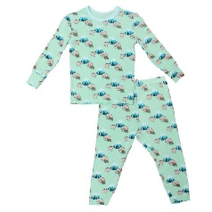

*Save time this morning and wear your pajamas, robes, and slippers to school. Students may wear sweatpants and sweatshirts also.*

**Tuesday** – Crazy Hair/Hat Day 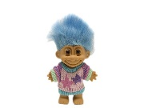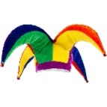

Let’s see those silly hats and hairstyles! Students wear uniforms this day.

***Wednesday*** – Mismatch Day 

A striped shirt and polka dot pants, one red and one purple sock….the possibilities are endless!

**Throwback Thursday** 

Dress from your favorite decade (1920’s, 30’s. 40’s. 50’s, 60’s. 70’s. 80’s. 90’s)

**Friday** – Lakers Pride Day 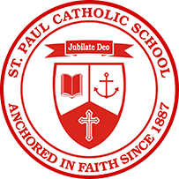

Wear your St. Paul Lakers shirts (or Lakers colors if you don’t have any gear yet) with jeans or sweatpants.